11th MAY 2022 CSC221

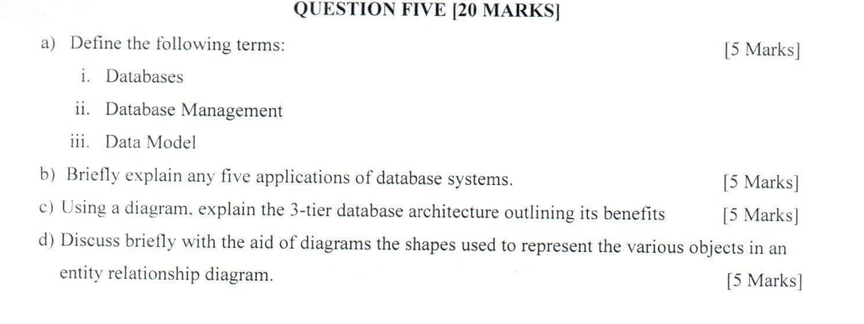a) Definitions:

i. Databases: Databases are organized collections of data, typically stored electronically in a computer system. They are structured to facilitate the efficient retrieval, insertion, and management of data.

ii. Database Management: Database Management involves the administration, organization, and maintenance of databases. It includes tasks such as data storage, retrieval, security, and ensuring the integrity of the data.

iii. Data Model: A data model is a conceptual representation of the data structures, relationships, and constraints that govern the storage and organization of data in a database. It provides a framework for understanding and designing databases.

b) Applications of Database Systems:

1. Banking Systems: Used for storing customer account information, transaction records, loan details, etc.

2. E-commerce Websites: Manage product catalogs, customer orders, payment processing, and inventory management.

3. Human Resource Management: Store employee records, payroll information, attendance data, performance evaluations, etc.

4. Healthcare Systems: Maintain patient records, medical history, prescriptions, appointment scheduling, and billing information.

5. Telecommunication Networks: Manage subscriber data, call records, network configurations, and billing information.

c) 3-Tier Database Architecture:

Benefits:

- Scalability: Each tier can be scaled independently, allowing for better resource utilization.

- Modularity: Clear separation of concerns facilitates easier maintenance and updates.

- Security: Enhanced security measures can be implemented at each tier, protecting sensitive data.

- Performance: Distributed processing reduces bottlenecks and improves overall system performance.

d) Entity Relationship Diagram (ERD) Objects Representation:

- Entity: Represented by rectangles, typically labeled with nouns, representing real-world objects like a person, place, thing, or concept.

- Attribute: Represented by ovals, indicating properties or characteristics of entities.

- Relationship: Represented by diamonds, connecting entities and showing how they are related. Labels on the lines describe the nature of the relationship (e.g., one-to-one, one-to-many, many-to-many).

- Key Attribute: Underlined attribute within an entity, indicating a unique identifier.

- Weak Entity: Represented similarly to entities but with a double rectangle border, indicating dependence on another entity for identification.

- Multivalued Attribute: Represented by double ovals, indicating attributes that can hold multiple values for a single entity instance.

- Derived Attribute: Represented by dashed ovals, indicating attributes whose values can be derived from other attributes.

Question TWO  
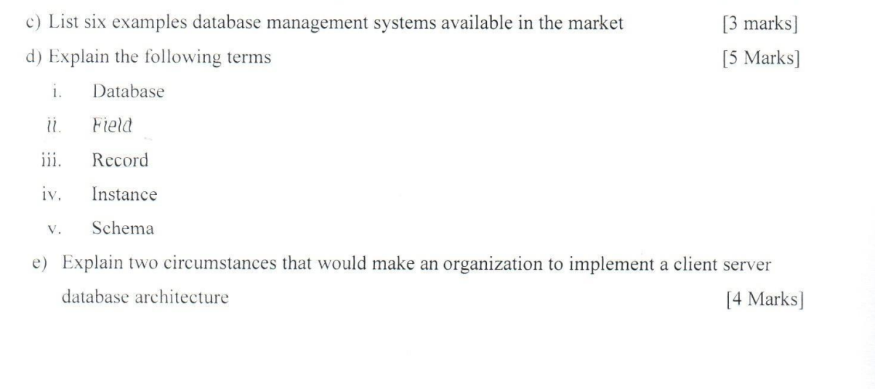 ### Explanation of Terms:

1. **Database:** A structured collection of data that is organized and managed to serve various purposes. It acts as a centralized repository for storing, managing, and retrieving data.

2. **Field:** A single piece of data within a database record, representing an attribute or characteristic. Fields define the properties or attributes of the entities in a database.

3. **Record:** A complete set of fields containing all the data about a particular entity or object in a database. It represents a single instance of the data structure defined by the database schema.

4. **Instance:** An occurrence of a database entity represented by a record. It is a specific occurrence or realization of the data model defined by the schema.

5. **Schema:** A logical description or blueprint of the entire database, including tables, fields, relationships, constraints, and indexes. It provides a framework for organizing and structuring data in a database.

### Circumstances for Implementing Client-Server Database Architecture:

1. **Scalability Requirements:** In situations where an organization experiences growth in data volume or user base, a client-server architecture becomes advantageous. By distributing the workload between clients and servers, the organization can scale its infrastructure to handle increased demand efficiently. This scalability ensures that adding more clients to the system does not significantly impact the overall performance of the server, facilitating seamless data access and retrieval.

2. **Security and Access Control:** Implementing a client-server database architecture is beneficial when strict security measures and access control are paramount. By centralizing data on a server, administrators can exert better control over user permissions, authentication processes, and data encryption. This centralized control enhances data security, ensuring that only authorized users can access specific information. Additionally, it aids in maintaining data integrity, confidentiality, and compliance with regulatory standards by enforcing security policies at the server level.